DOCUMENTATION ON CENTURA TECHNOLOGY WEBPAGE

* **Screenshot of hero section Navbar**



* **Navbar : dropdown of Services**.



* **Hero Section of Website.**



* Footer Section

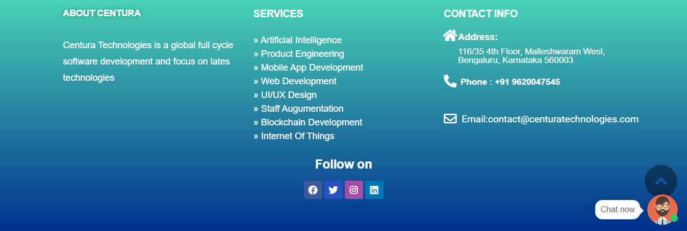

* Home page 2nd section



* Home page 3rd section

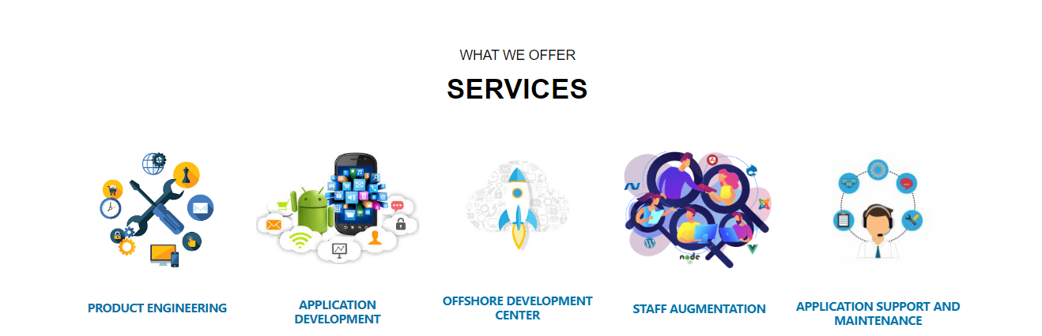

* In the above blocks, all the subheadings are hyperlinks which navigate to next pages.
* Home page 4th Section

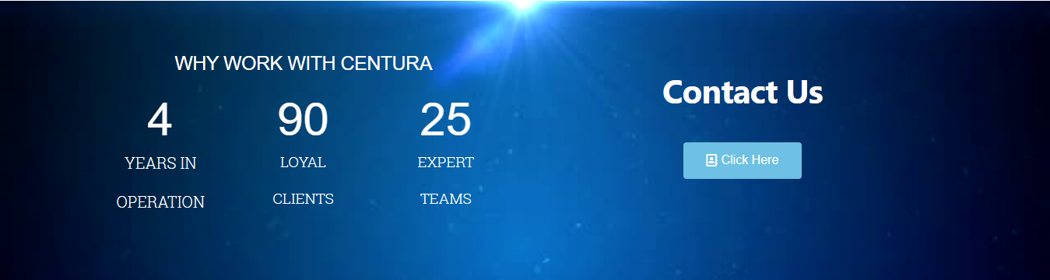

* Home page 5th Section



* Common end Section before footer for other elements in navbar

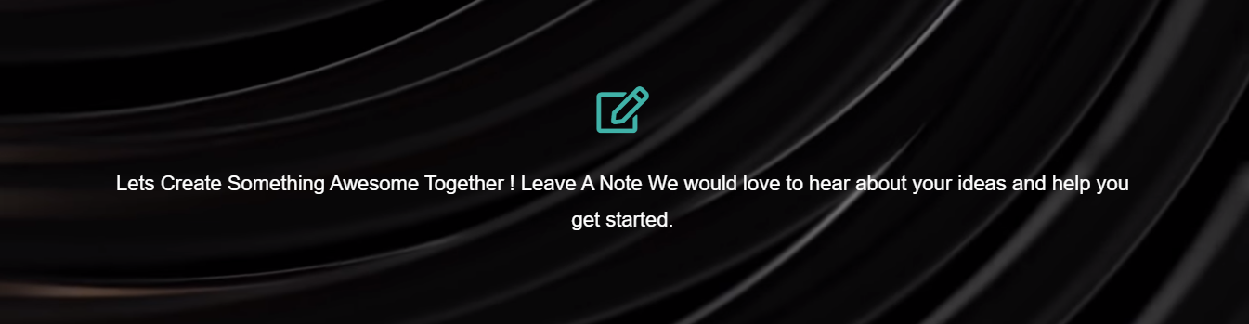

* The background vedio is running in the above section.

**Second element in the navbar i.e Services:-**

**Under Services, In dropdown first option Artificial Intelligence**.

* Artificial Intelligence: 1st Section

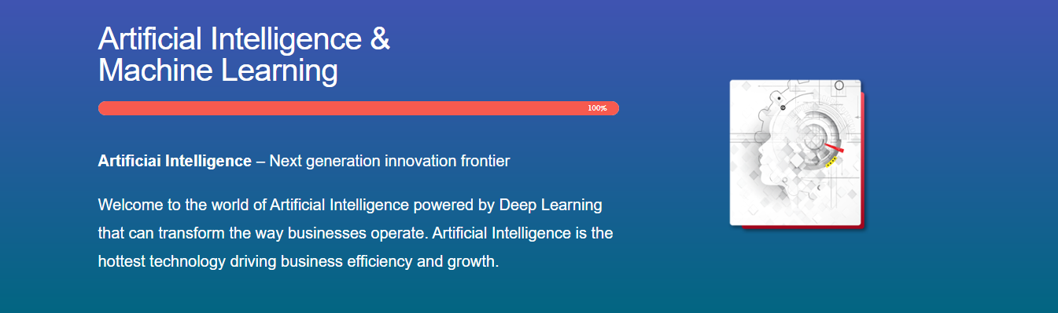

* Artificial Intelligence: 2nd Section



* The second section of artificial intelligence is the tab section section. It works as per onclick function.

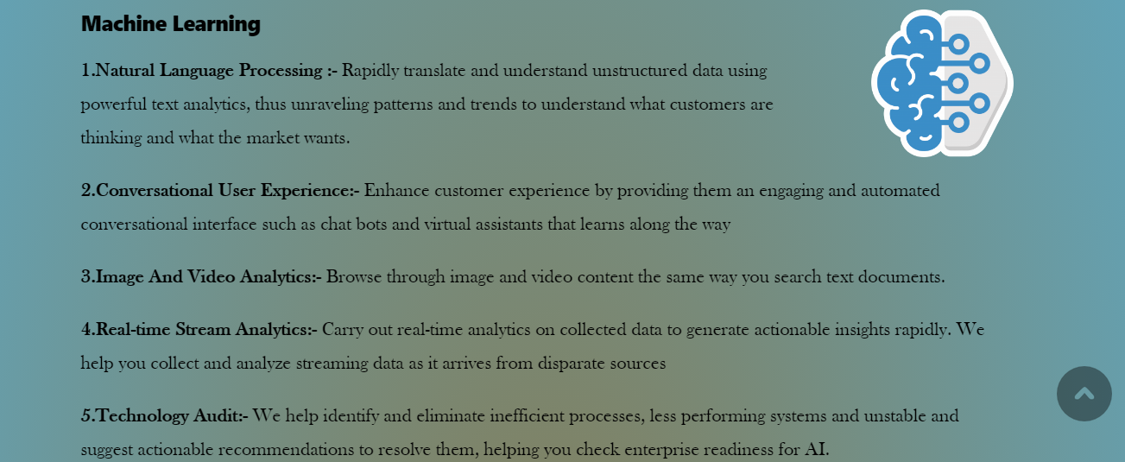

**Under Services, In dropdown second option Product Engineering.**

* Product Engineering: 1st Section

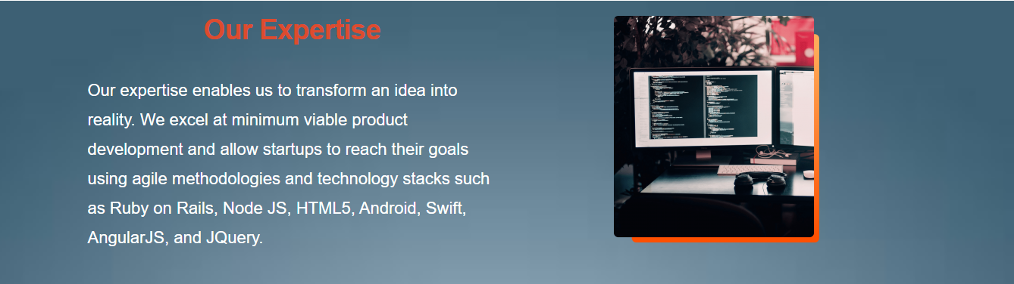

* Product Engineering: 2nd Section



* Product Engineering: 2nd Section – Continuation

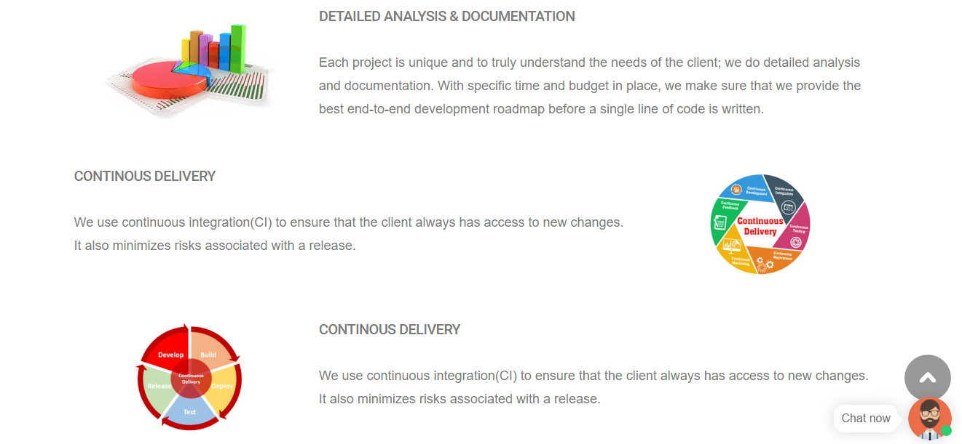

* Product Engineering: 2nd Section – Continuation

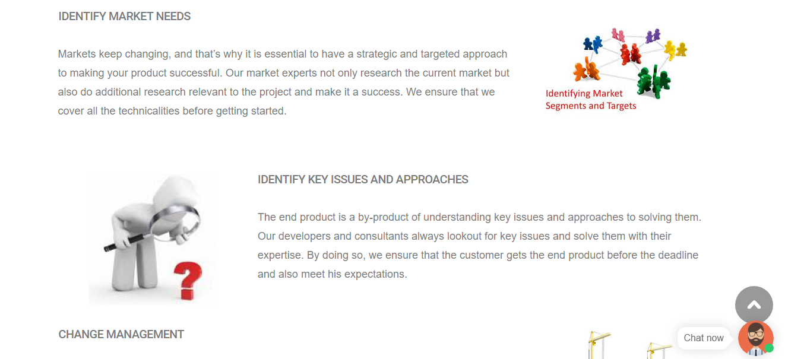

* Product Engineering: 2nd Section – Continuation

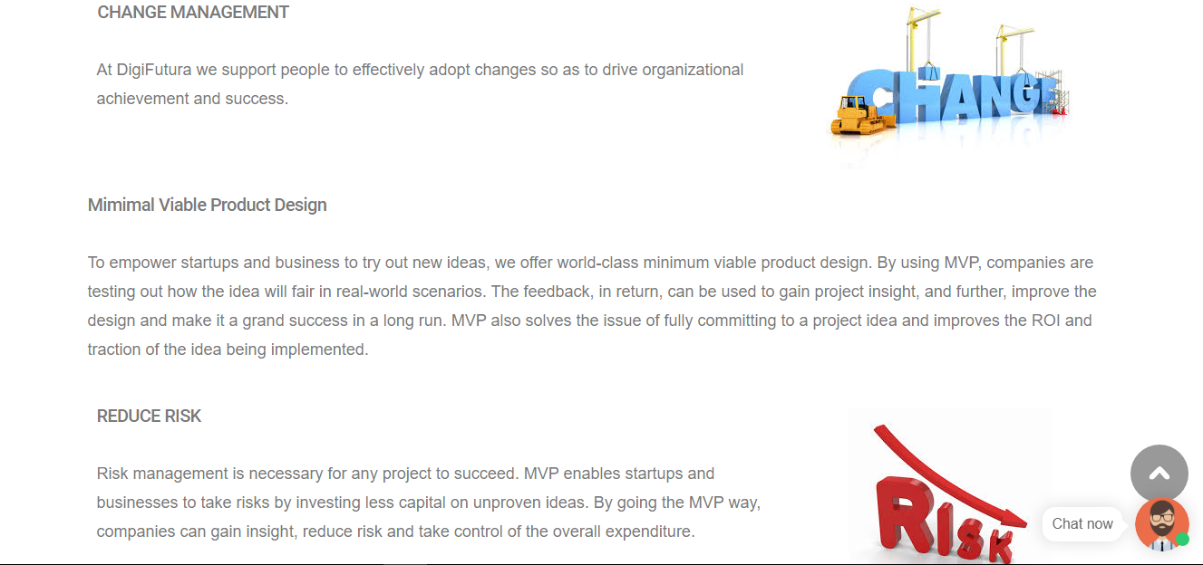

* Product Engineering: 2nd Section – Continuation

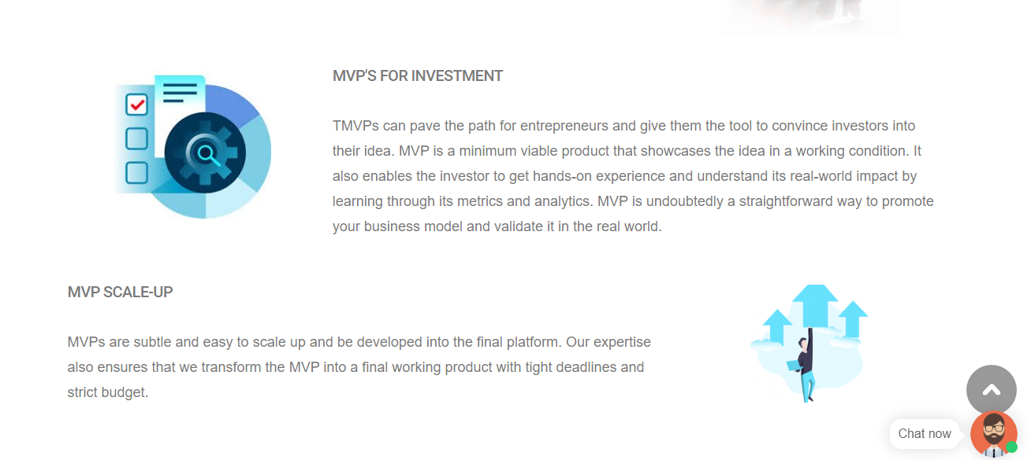

**Under Services, In dropdown Third option Mobile App Development**.

* Mobile App Development–1st  Section



* Mobile App Development–2nd Section

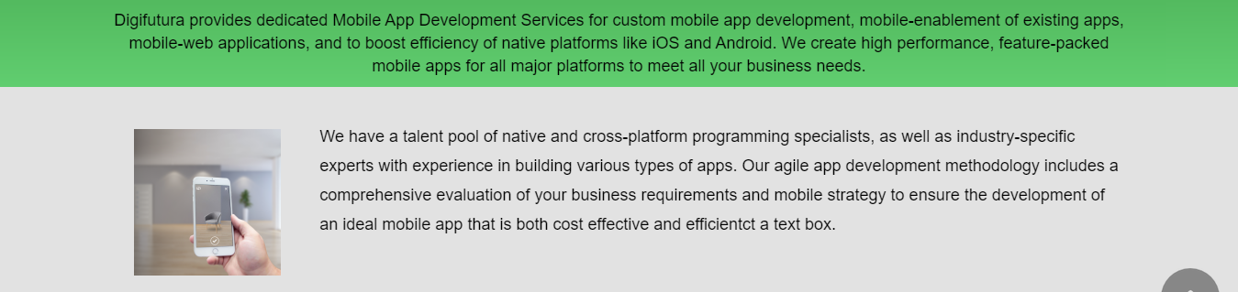

* Mobile App Development–3rd Section

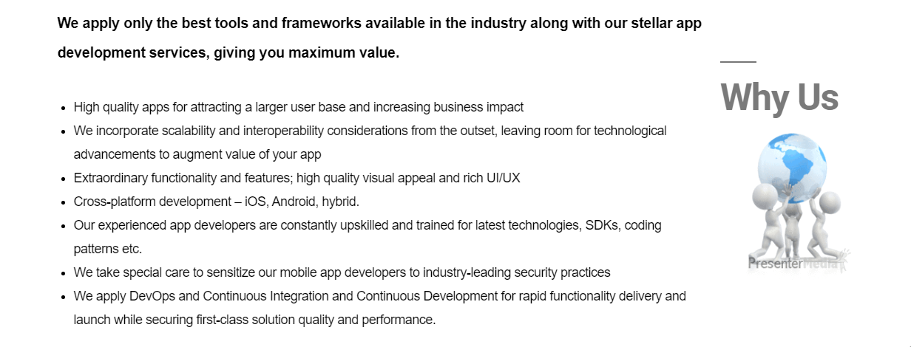

* Mobile App Development–4th Section

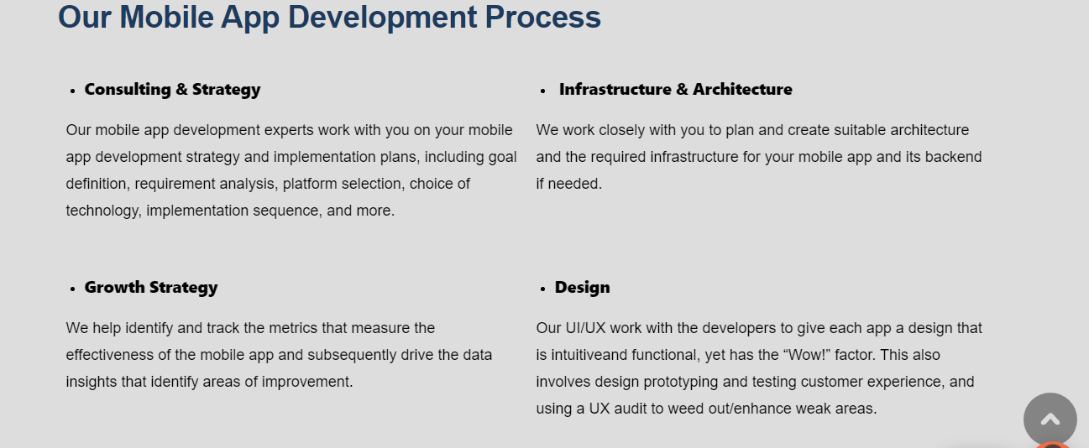

* Mobile App Development–5th Section

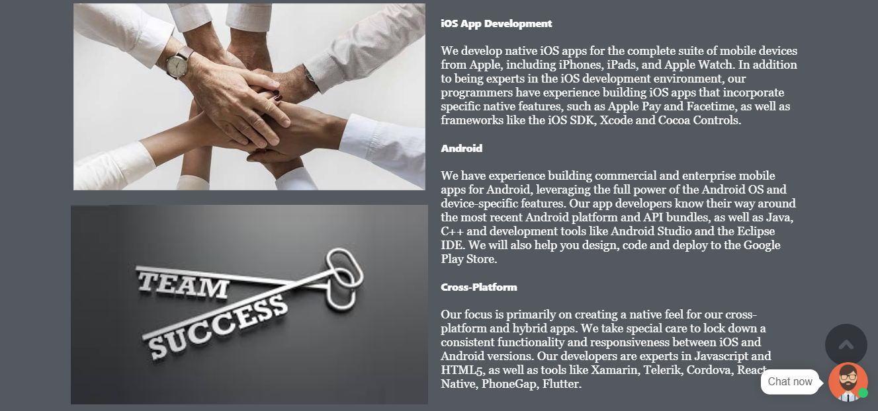

**Under Services, In dropdown Fourth option Web App Development.**

* Web App Development: 1st Section



* Web App Development: 2nd Section

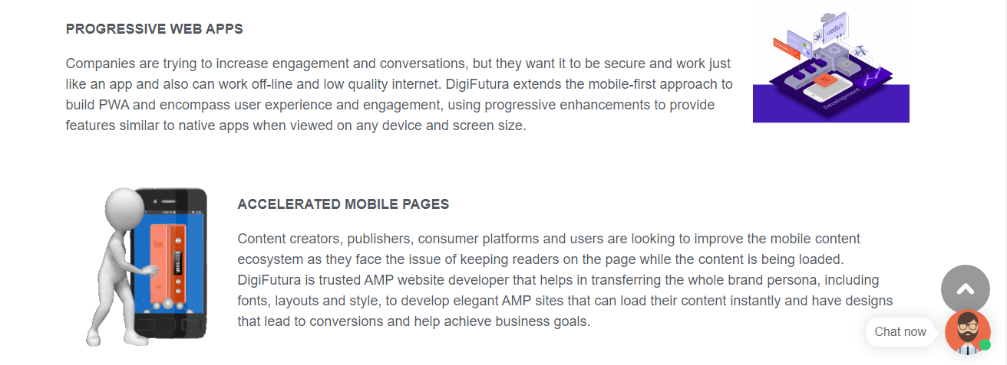

* Web App Development: 2nd Section–Continuation

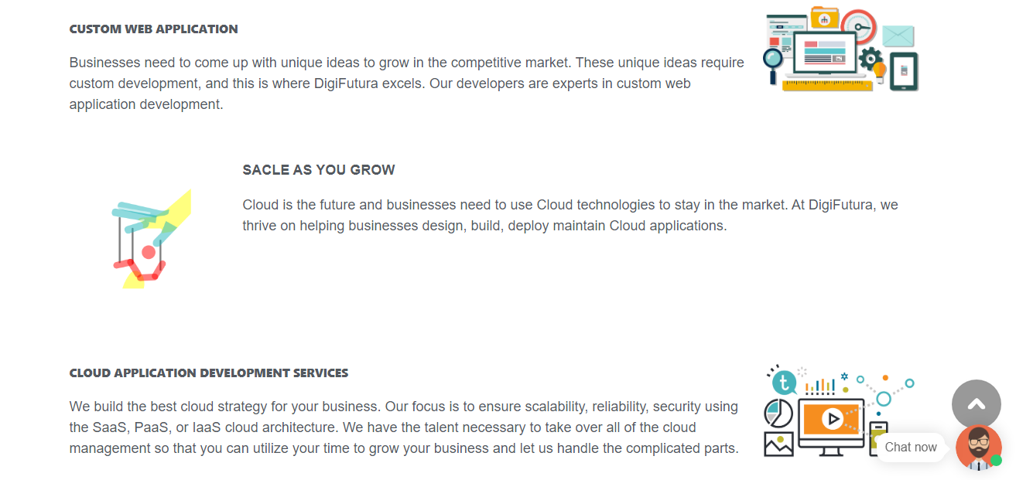

**Under Services, In dropdown Fifth option UI/UX Design.**

* UI/UX Design: 1st Section



* UI/UX Design: 2nd Section

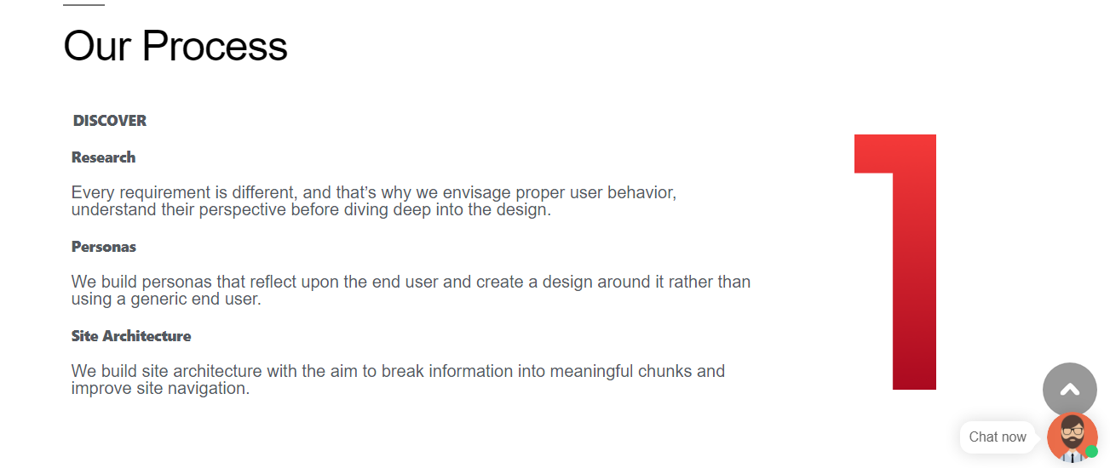

* UI/UX Design: 2nd Section–Continuation

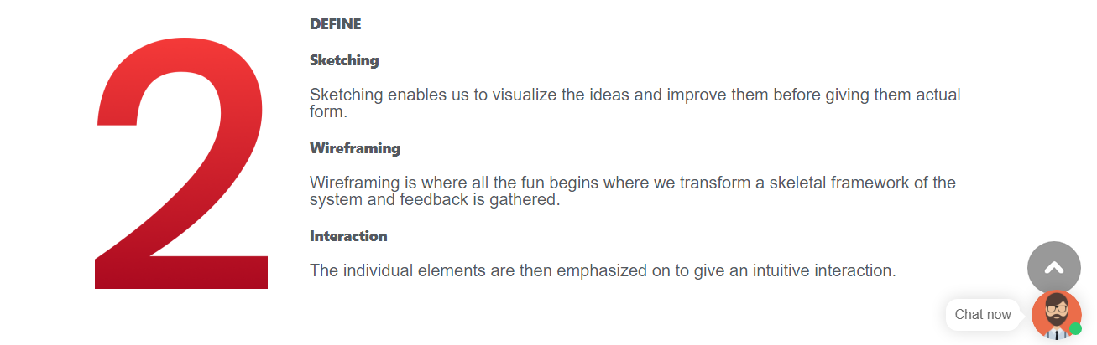

* UI/UX Design: 2nd Section–Continuation

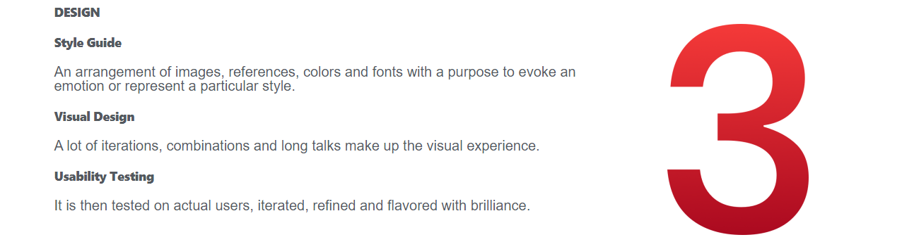

**Under Services, In dropdown Sixth option Staff Augumentation.**

Staff Augumentation: 1st Section- Slider1

* Here is the section containing Smart slider images.



* Staff Augumentation: 1st Section- Slider2

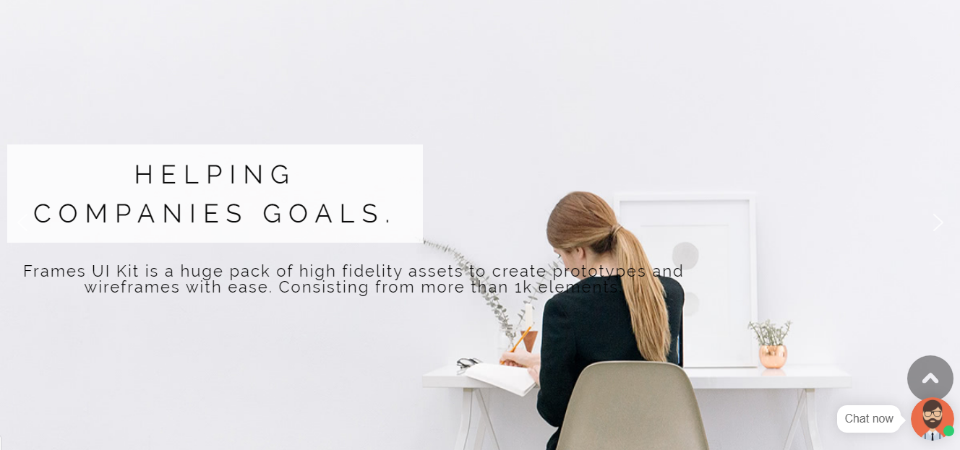

* Staff Augumentation: 1st Section- Slider3



* Staff Augumentation: 2nd Section

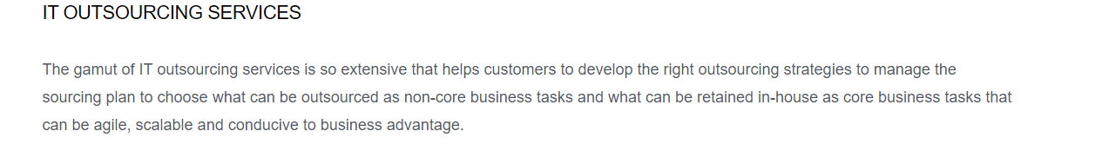

* Staff Augumentation: 3rd Section



* Staff Augumentation:4th Section

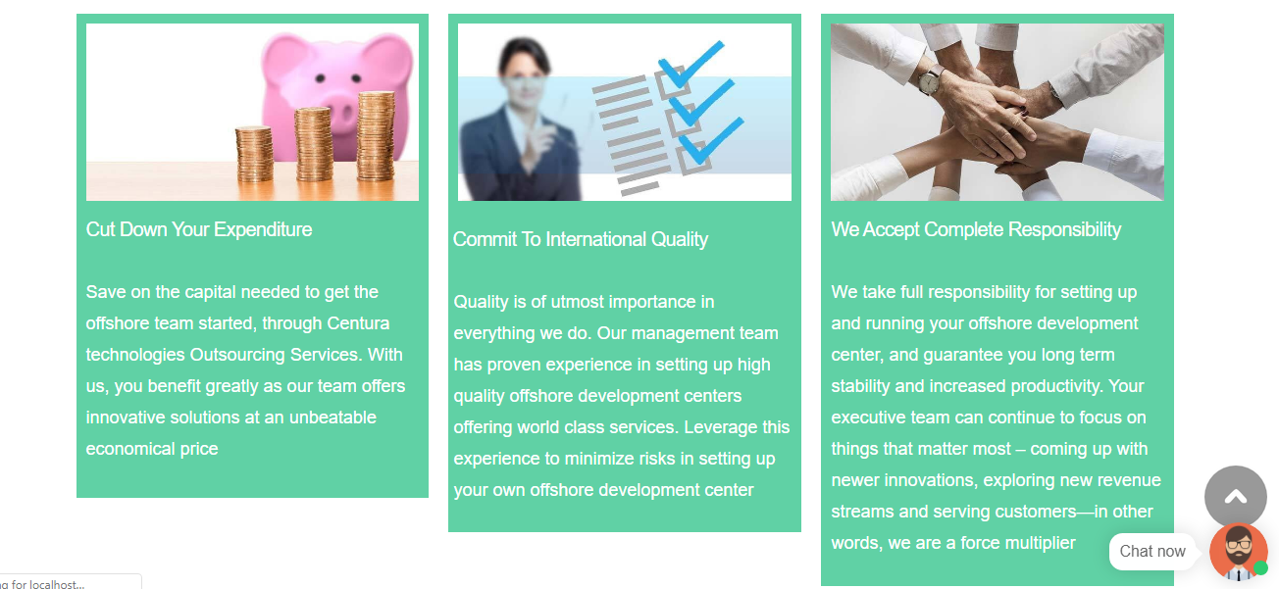

* Staff Augumentation: 5th Section



* Staff Augumentation:5th Section- Continuation

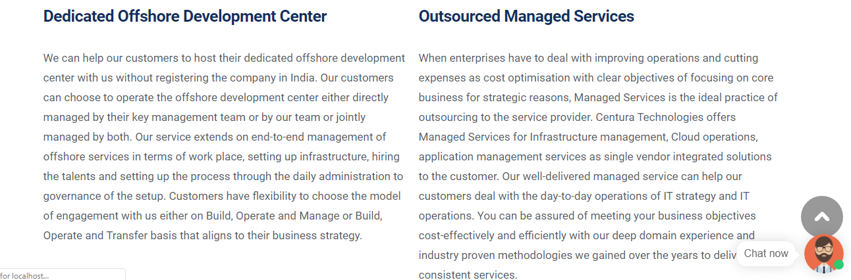

* Staff Augumentation:6th Section



* Staff Augumentation:7th Section



* Staff Augumentation:8th Section

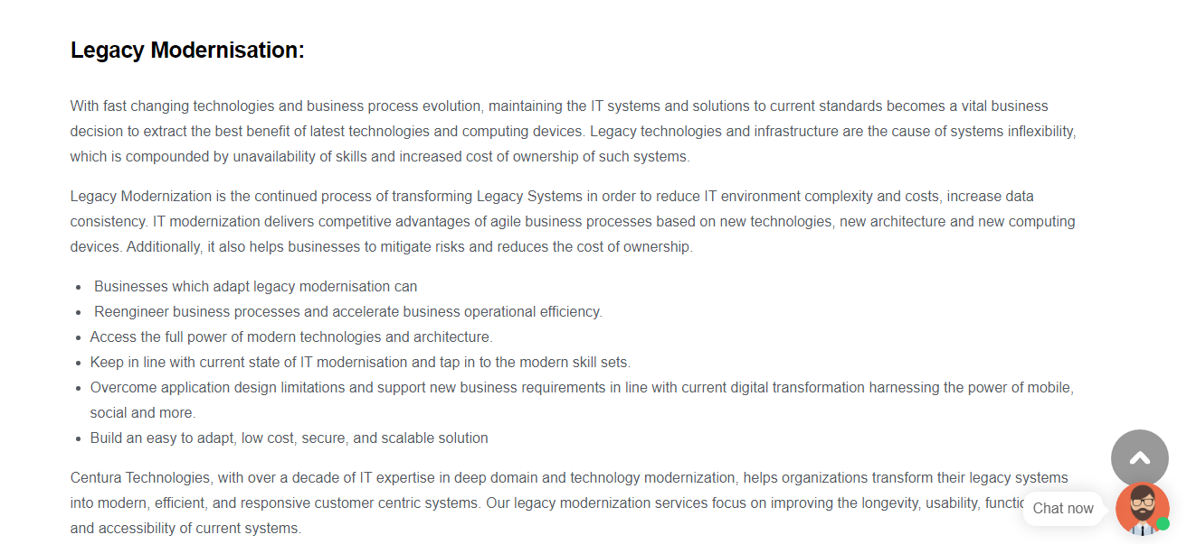

* Staff Augumentation: 8th Section- Continuation



* Staff Augumentation:8th Section



**Third element in the navbar i.e About Us:-**

* About Us: 1st Section



* About Us: 2nd Section
* In this section contains tabs as follows- Tab1

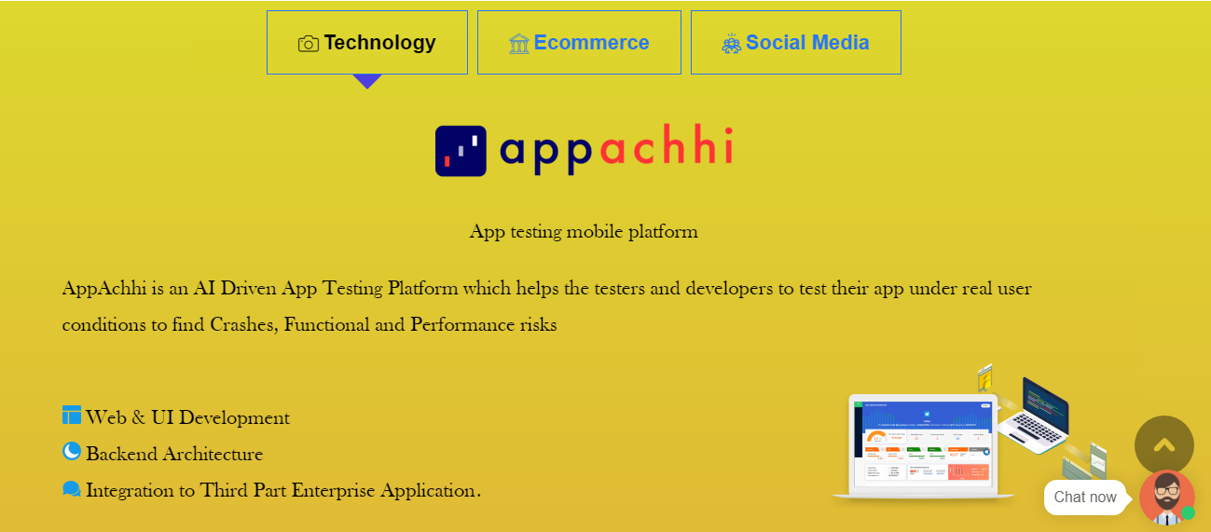

* About Us: 2nd Section-Tab2

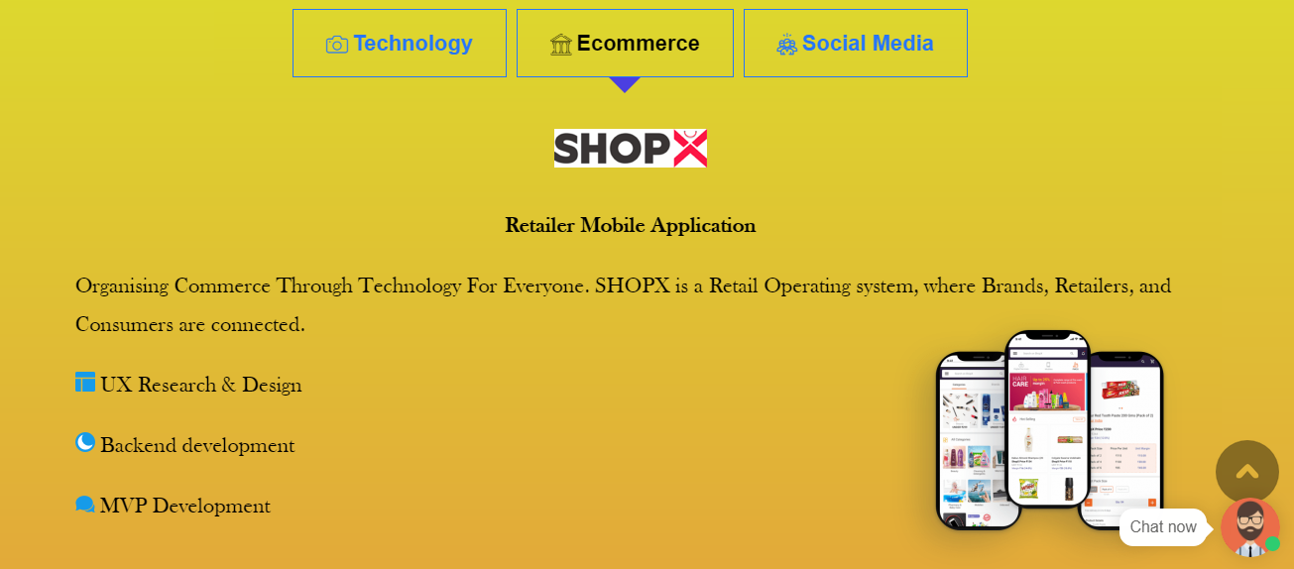

* About Us: 2nd Section-Tab3

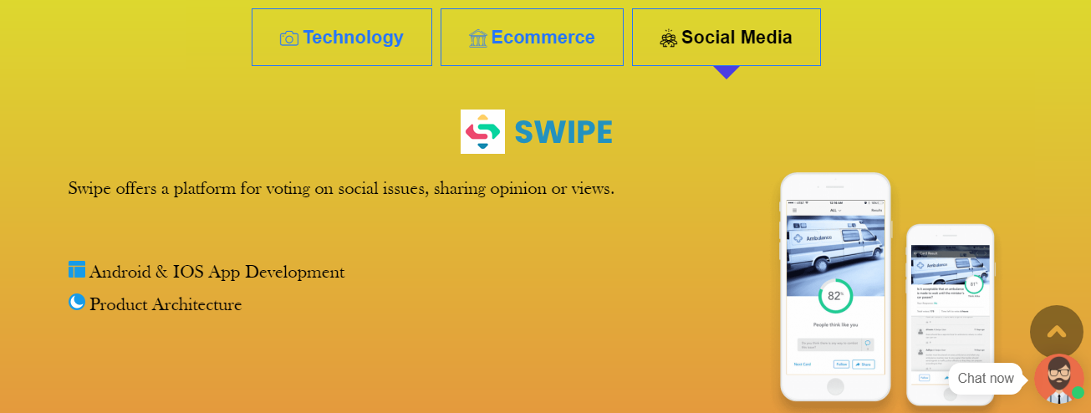

* About Us: 2nd Section-Tab3-Continuation

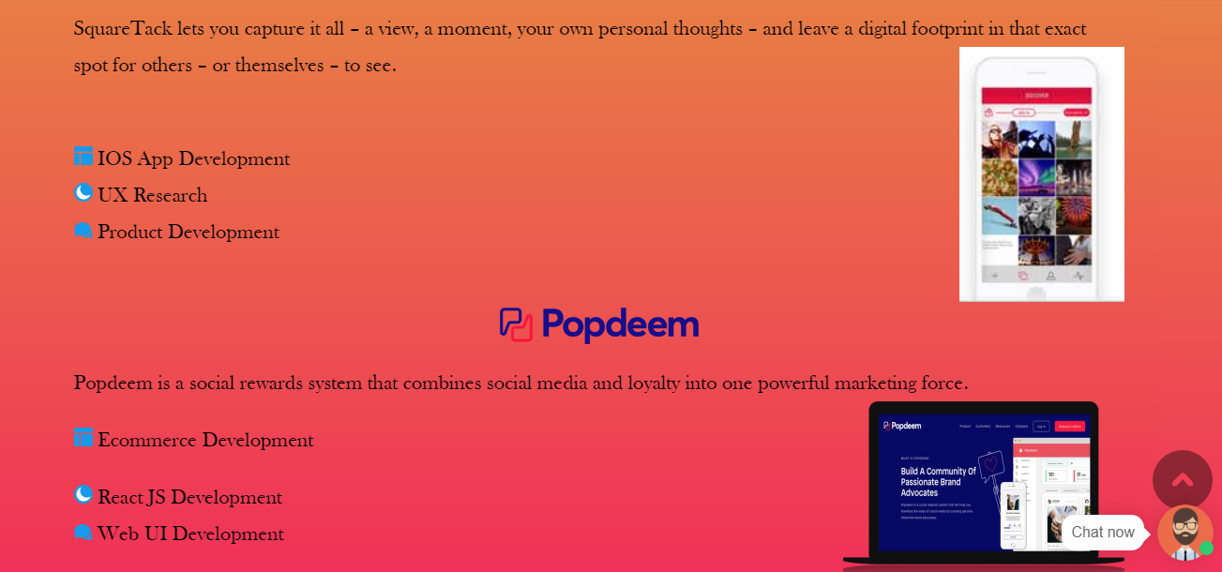

* About Us: 2nd Section-Tab2-Continuation

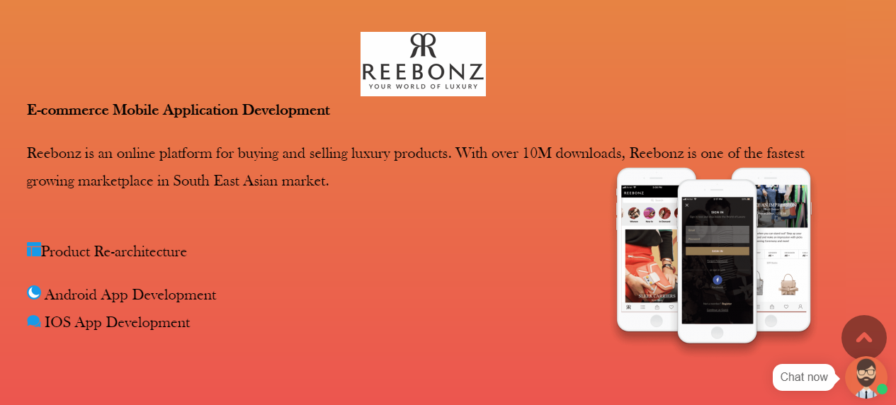

* About Us: 2nd Section-Tab1-Continuation

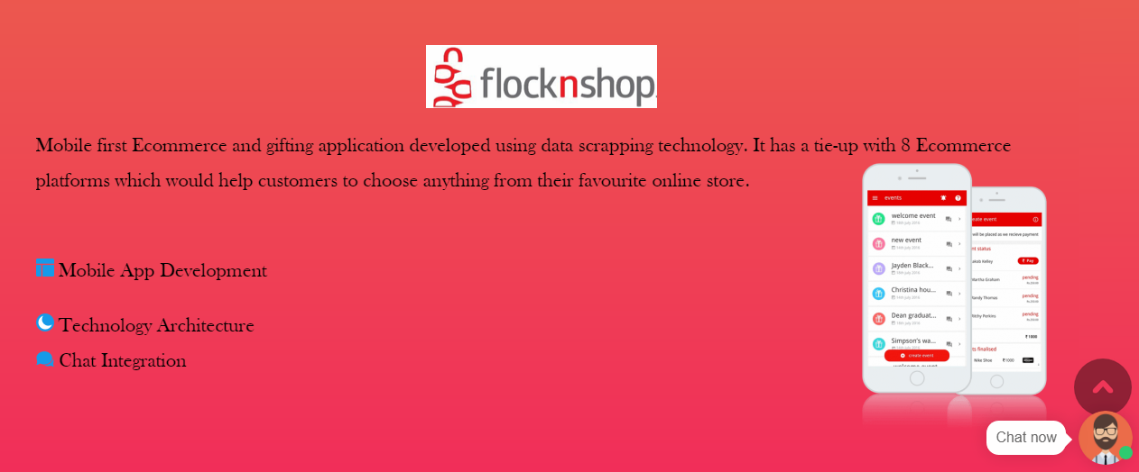

**Fourth element in the navbar i.e Careers:-**

* In the careers element, there is a dropdown which have options like follows



**Under Company, In dropdown first option is Blog.**

* Blog: 1st Section



Blog:2nd  Section

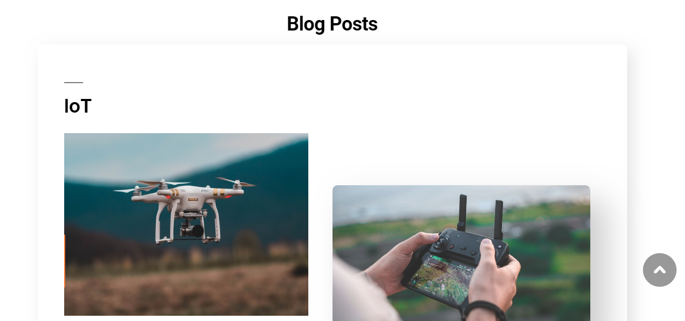

* Blog:2rd Section-Continuation

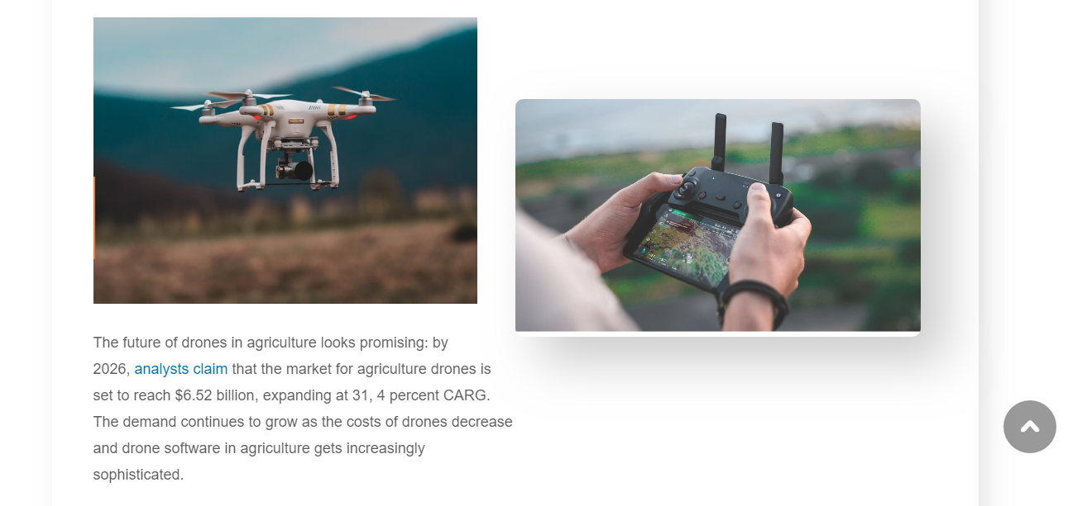

* Blog:3rd Section

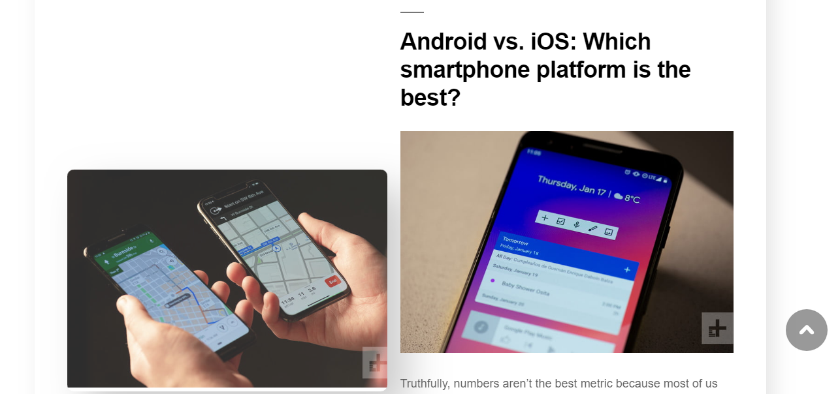

* Blog:3rd Section-Continuation

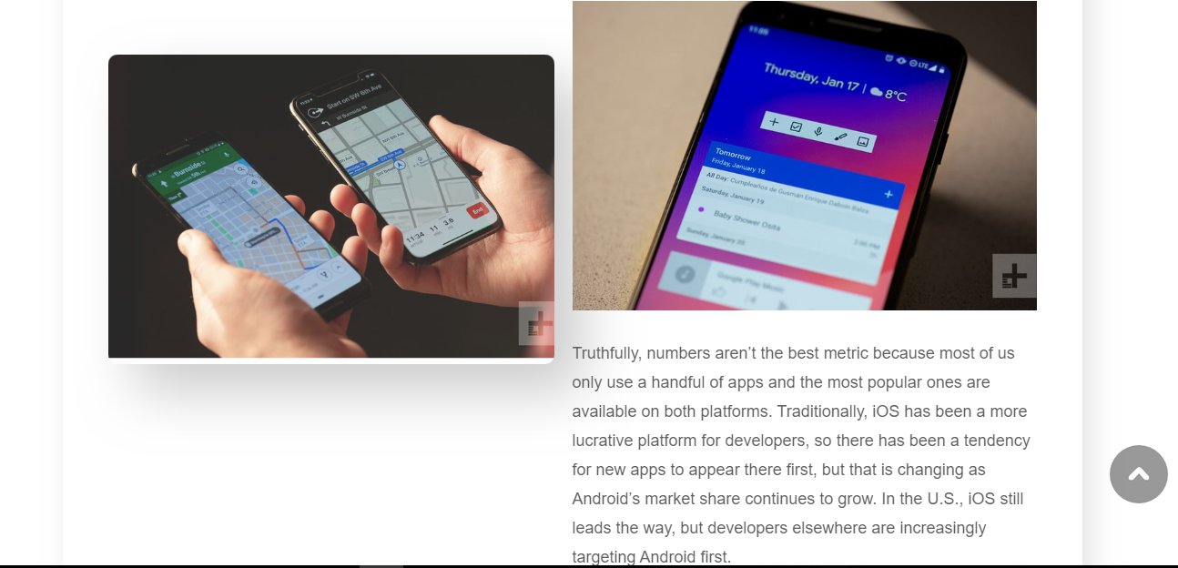

* Blog:4th Section

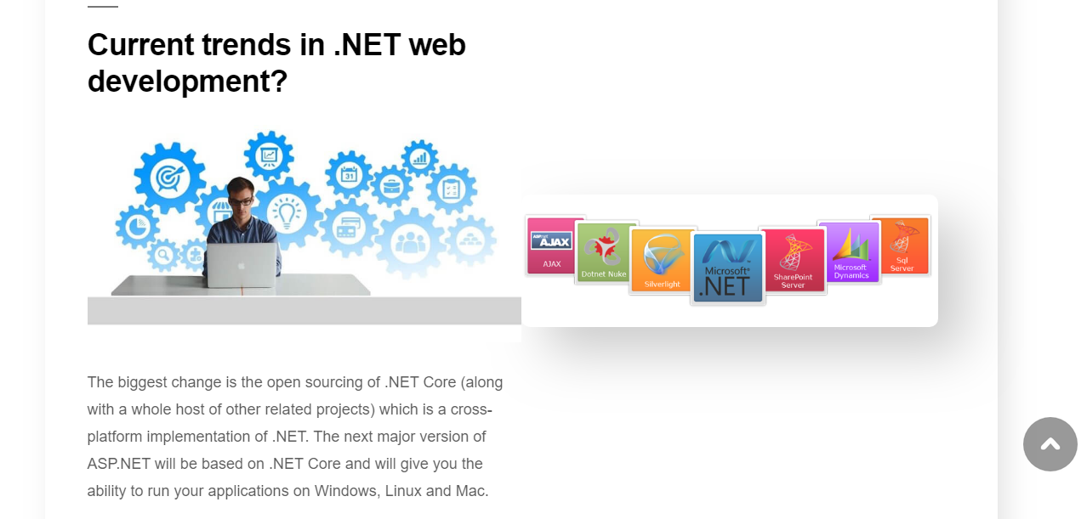

* Blog:5th Section
* This section is smart slider-slider1

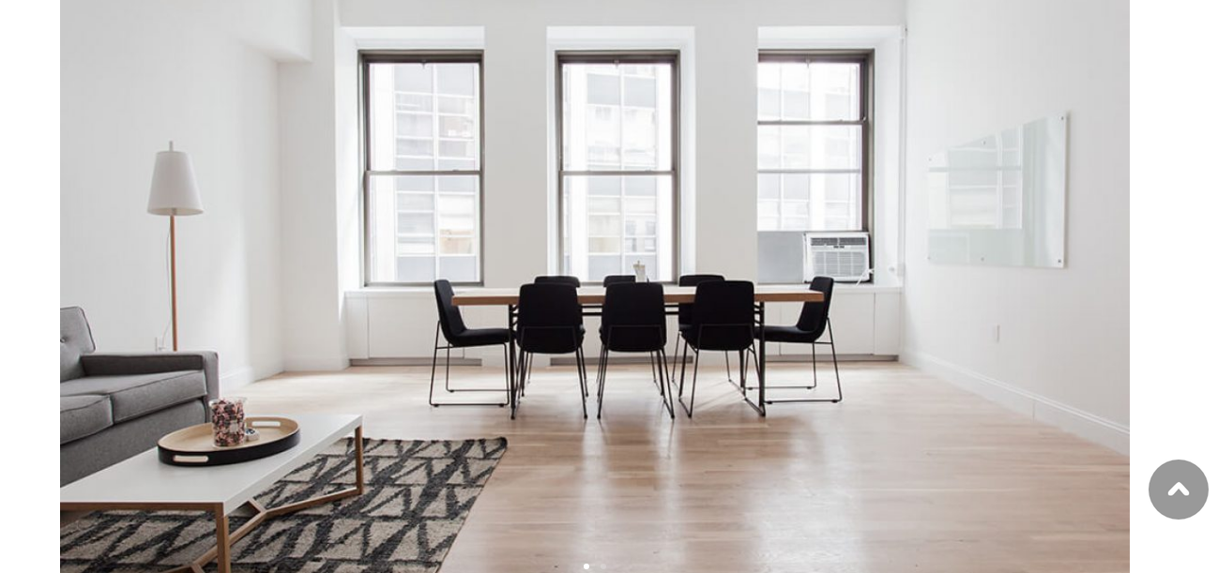

* Blog:5th Section-Slider2



* Blog:5th Section-Continuation

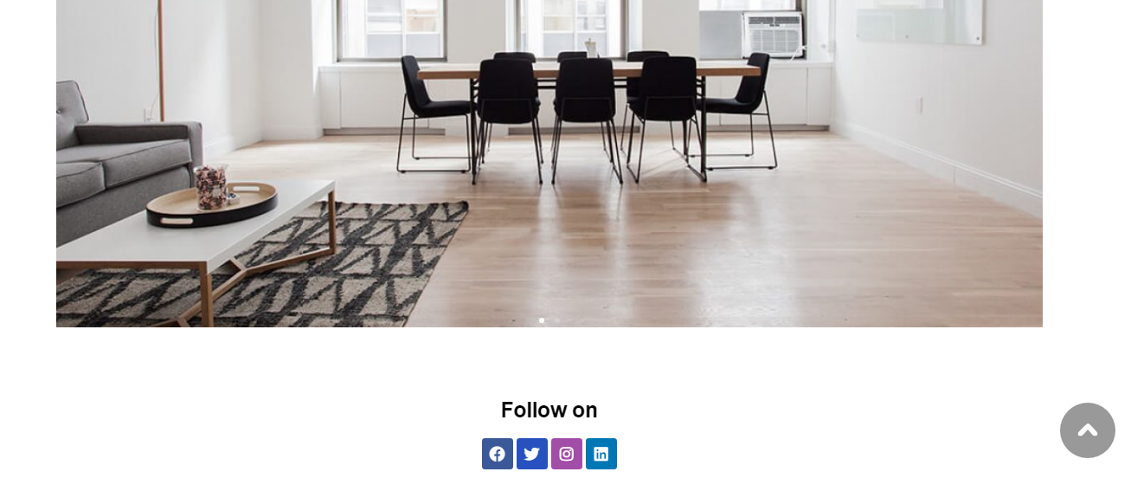

**Under Company, In dropdown Second option is Careers.**

* Careers:1st Section



* Careers:2nd Section
* In this below section, it consists of tabs as follows: Tab1

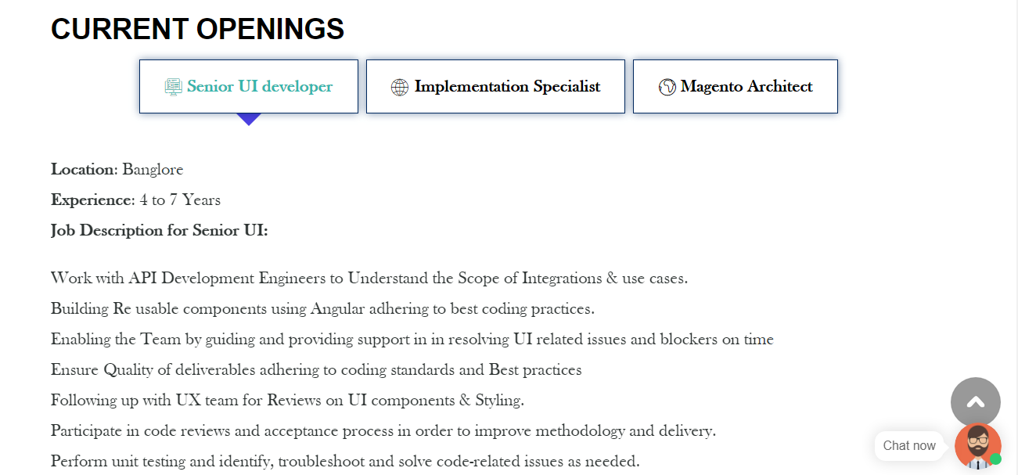

* Careers:2nd Section-Tab1-Continuation

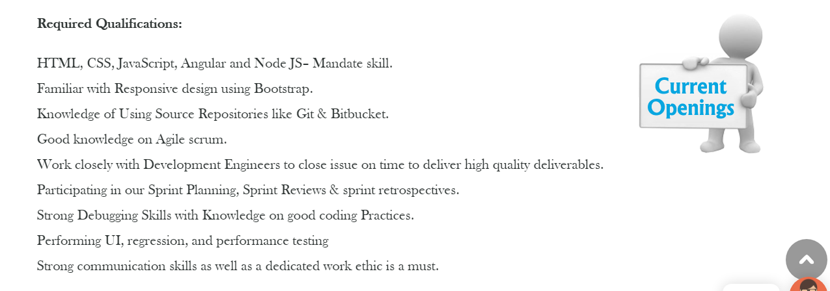

* Careers:2nd Section-Tab2

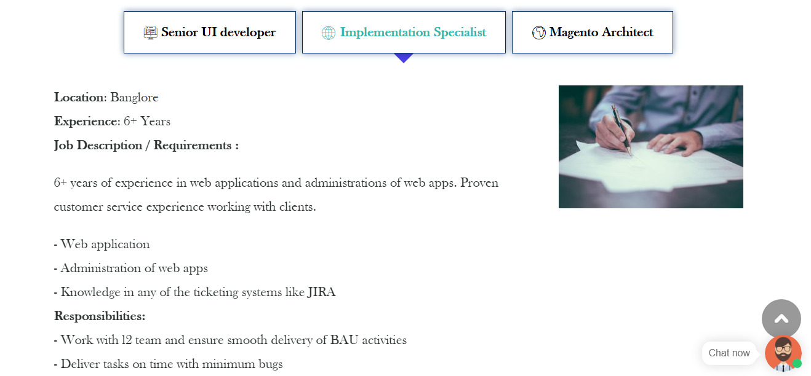

* Careers:2nd Section-Tab2-Continuation

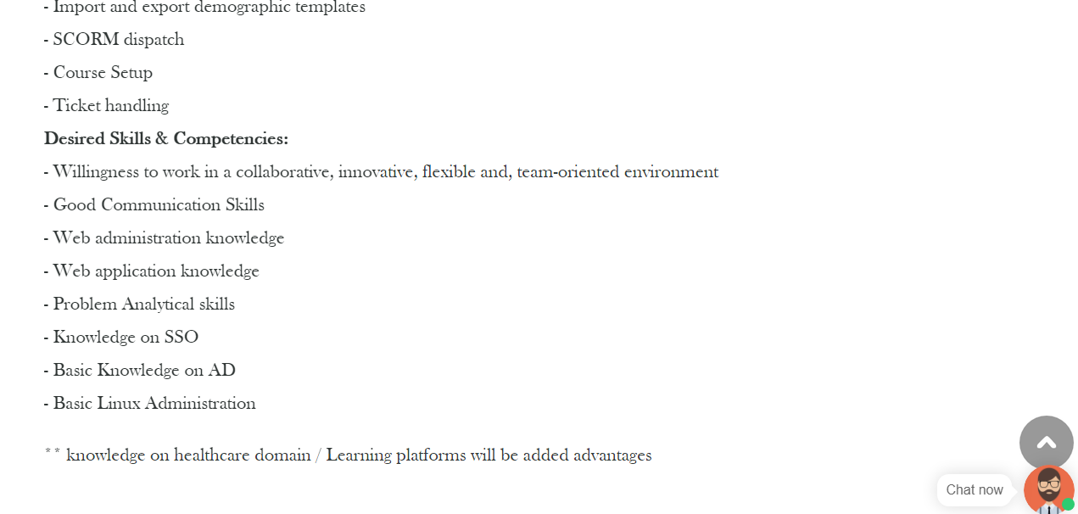

* Careers:2nd Section-Tab3

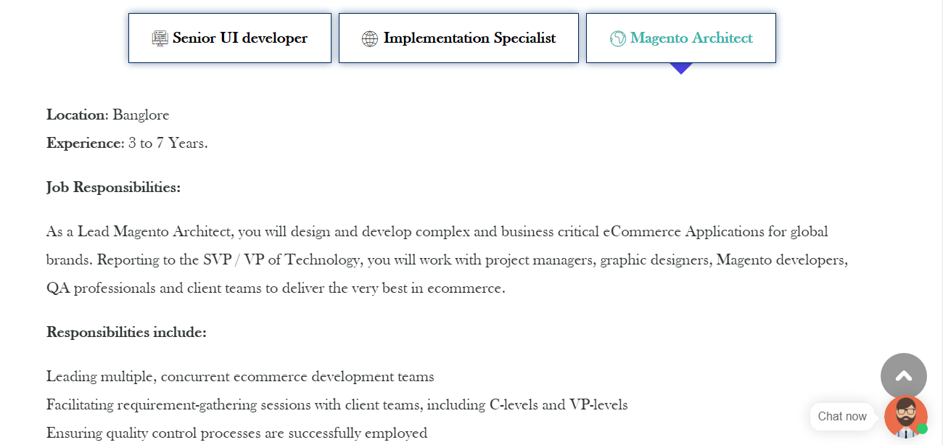

* Careers:2nd Section-Tab3-Continuation

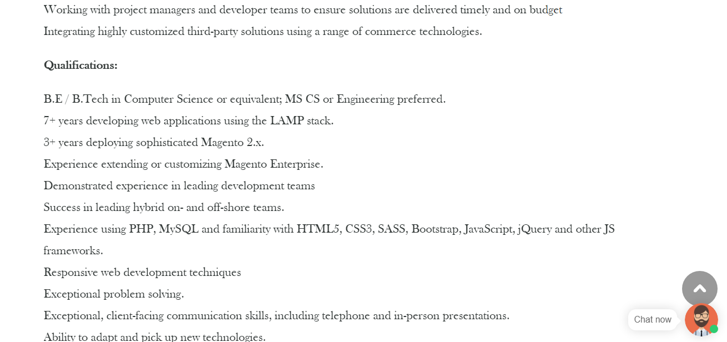

* Careers:3rd Section

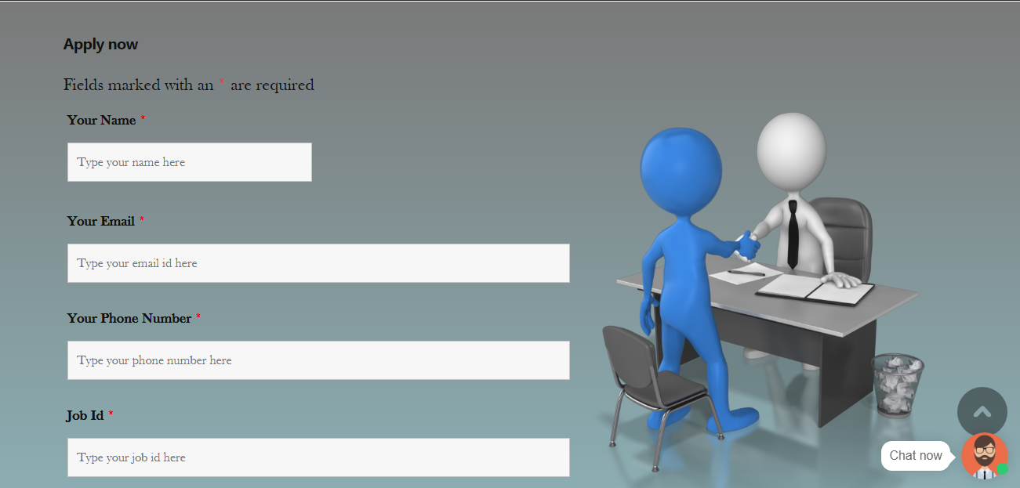

* Careers:3rd Section –Continuation

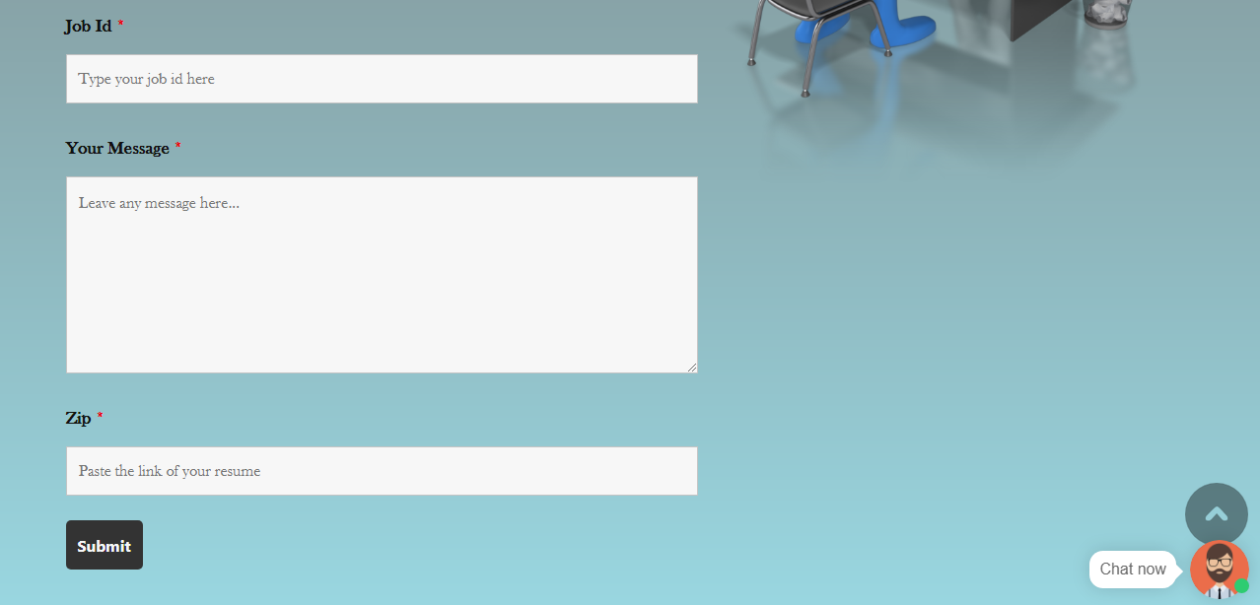

* Careers:3rd Section –Continuation

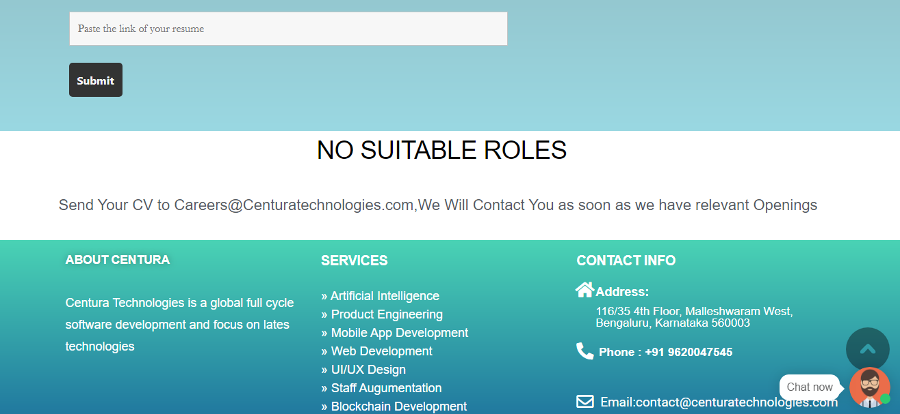

**Under Company, In dropdown Third option is Management Team.**

* Management Team:1st Section



* Management Team:2nd Section

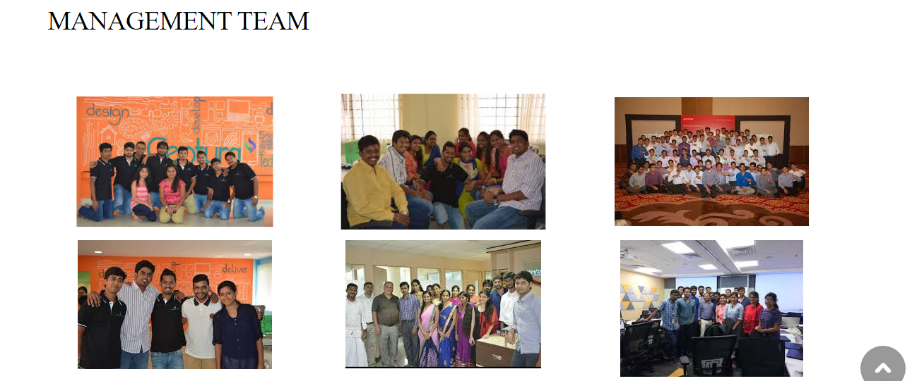

**Fifth element in the navbar i.e About Us:-**

* About Us:1st Section



* About Us:2nd Section



* About Us:2nd Section-Continuation

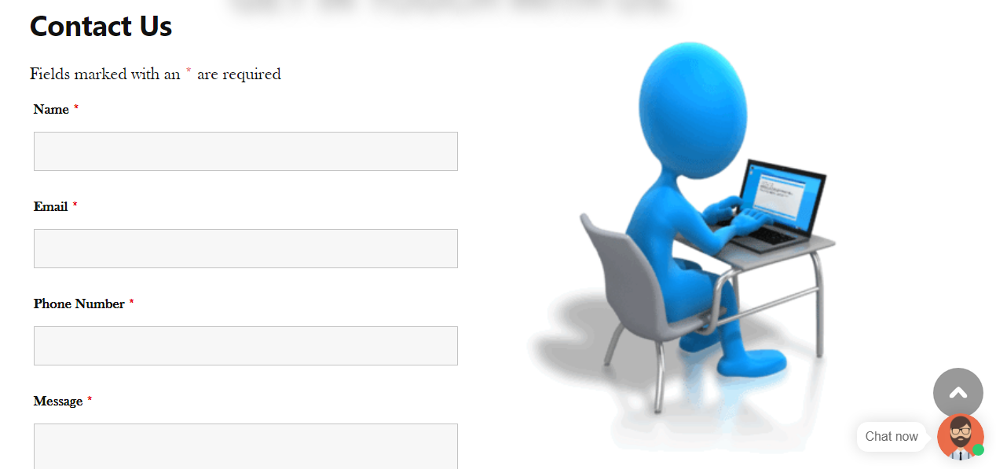

* About Us:3rd Section

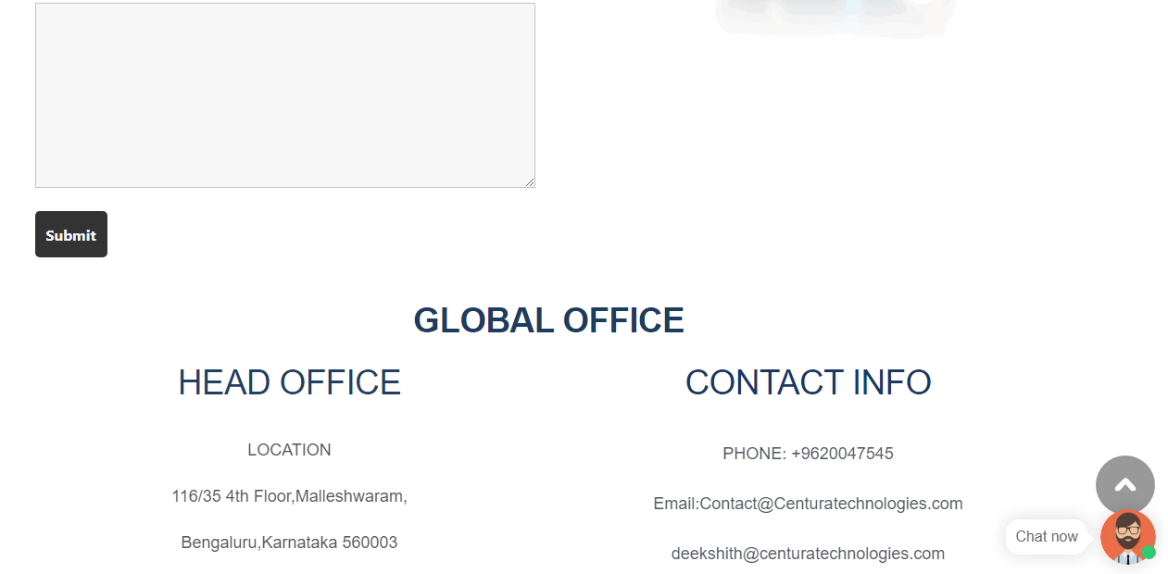

* About Us:4th Section

